Reversing APKs
What is reversing?
Reversing is the process of transforming a compiled application back to something resembling to the original code, that will allow us to look for hard-code secrets in the application and get deeper understanding of it.

APKTool
APKTool is an open-source tool for reversing android APKs.
Require to have java installed
Java -jar apktool.jar d example.apk
‘d’ is for decode
The result will be file with the same name as the application.
Your APK file can contain just one AndroidManifest.xml file, but your Android Studio project may contain several—provided by the main source set, build variants, and imported libraries. So when building your app, the Gradle build merges all manifest files into a single manifest file that's packaged into your APK.
The manifest merger tool combines all XML elements from each file by following some merge heuristics and by obeying merge preferences that you have defined with special XML attributes. This page describes how manifest merging works and how you can apply merge preferences to resolve merge conflicts.
https://developer.android.com/studio/build/manifest-merge

Dex2jar
Dex2jar tool is an open-source project with for working with .dex and .class files. For our purposes we will use it to convert the classes.dex file to a .jar file.
Can be downloaded from here https://sourceforge.net/projects/dex2jar/
After unzip it you will see several different wrapper scripts for running the tool, for windows you will use the .bat files, for linux\mac the .sh versions.
Use the following command to decode the classes.dex file
./de2j-dex2jar.sh ../example.apk/classes.dex -o file.jar
Or you can run it directly on the apk file as follow
./de2j-dex2jar.sh ../example.apk -o file.jar

Jd-gui
Jd-gui is a simple tool capable of decompiling java.jar files and allowing you to browse through the source code of the .class files contained within. The tool can be downloaded from here
http://java-decompiler.github.io/
Procyon and fernflower are alternative tools which can also be used , you should note the some strings variable values won’t be correctly reconstructed, so don’t be surprised if you see the commonly used deadbeef placeholder.
After opening it from the file menu open classes_dex2jar.jar file that you created previously.
This will show you a hierarchical view of the contents on the left-hand side. You can drill down to the classes, by clicking the triangle icon to the left of the package name.
Example of original code and the same code after decompiling it. The full name and namespace is used, in the decompiled version of the resource is specified in the R class .
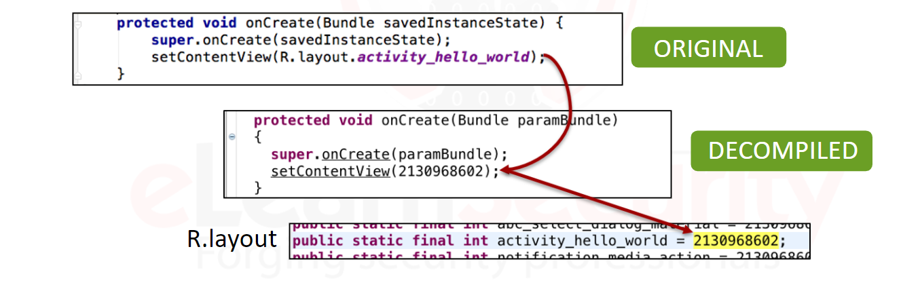

Smali and baksmli
Smali and baksmali are programs commonly referred to as an assembler and disassembler.
In android , the bytecode is in ,dex format, which , when disassembled by baksmali, produces an assembly language which is commonly referred to as smali code.
What is obfuscation ?
Is the process of intentionally making code harder to read for the purpose of making it more difficult to reverse.
This is usually done by developers wanting to protect their intellectual property, namely the code itself, but it is also a side effect of optimizing and minifying the code.
Minifying is generic term for reducing the size of the code, which can improve performance and reduce the app size.
It doesn’t guarantee any security at all.
Additional apk contents
Apktool.yml
- The version of apktool
- The original apk name
- Whether the apk is or uses a framework
Frameworks are development toolsets allowing for easily re-using the code to perform common or specialized function.
Hardware optimization
Sometimes when you reverse an apk you will find there is classes.dex, if the app was a pre installed app you will likely find a .odex file.
This is a pre-optimized version of the dex, which is specific to your hardware platform. The odex format is used to speed up the first boot of the rom.
The classes.dex was actually removed from the apk and disassembled.
In order to prevent the classes.dex file from being disassembled, you can specify the -s flag when running apktool
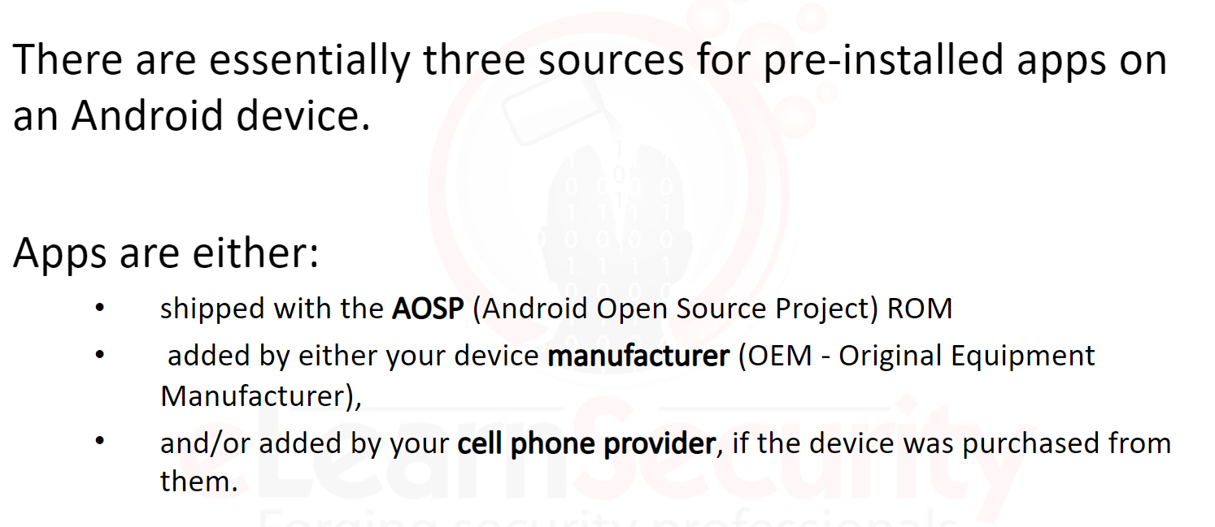
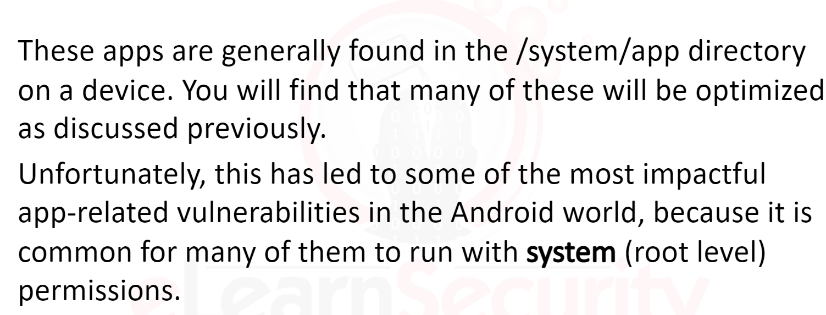
https://appsamurai.com/what-is-oem-what-opportunities-does-it-have-for-mobile-marketers/

